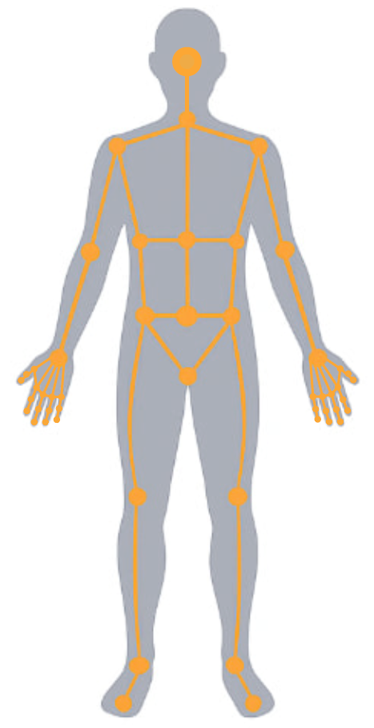
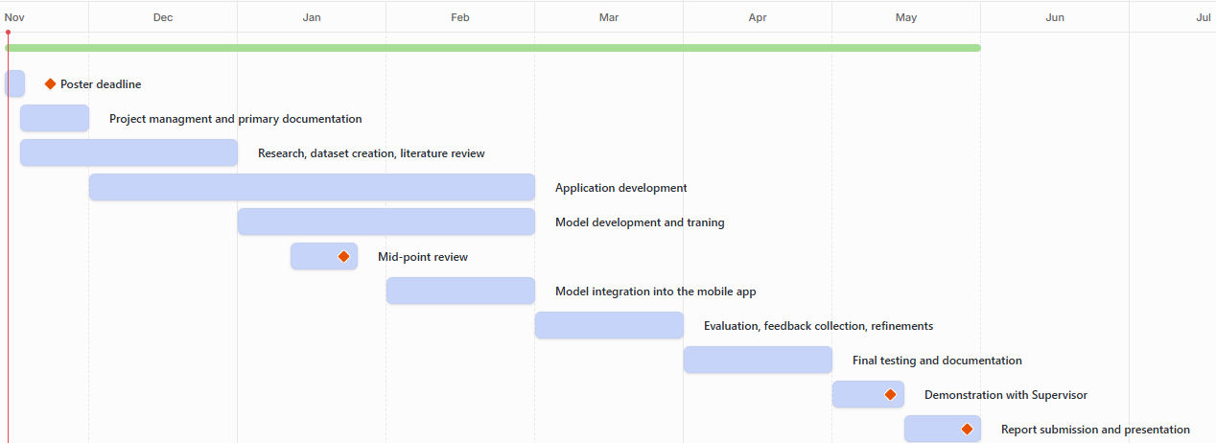
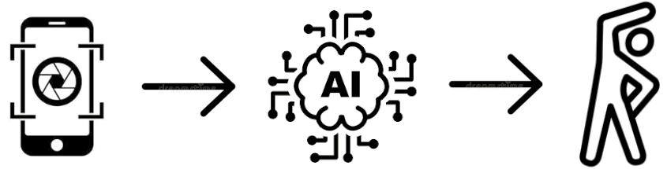
Problem Statement

Many gym-goers struggle with identifying exercises, especially when learning new ones. Remembering exercise names, understanding which muscles are involved, and tracking sets, reps, and weights can also be challenging and not always practical during a workout. Most existing fitness apps don't automatically recognize exercises, meaning users must know their names before saving, which disrupts the workout process. Additionally, many apps lack clear instructions or explanations, forcing users to search for this information elsewhere. These issues can make workouts less effective, more time-consuming, and tedious for users.

Key Dates:
- Poster Deadline: 17 November 2025
- Mid-Point Review: 20 January 2026
- Supervisor Demo: 12 May 2026
- Final Submission: 22 May 2026
Project Plan
Aims & Objectives
AI-Powered Gym Assistant: Real-Time Exercise Recognition and Storing

Prepared by: Artem Shkurat (SHK226612576)
Legal, Ethical & Professional Considerations

Since the app will use the phone's camera to recognize exercises, responsible handling of the recordings is crucial to ensure the privacy and protection of users' personal data.
To ensure this privacy, the app will be GDPR compliant, requiring users to provide consent before recording any videos, and no footage will be stored without permission. The app will not save or distribute videos without the user's explicit consent, mitigating the risk of privacy breaches.
To avoid problems with AI bias, the model will be trained using a large amount of diverse material, enabling it to recognize exercises regardless of gender, race, body type, and even clothing style.
The app will clearly inform users about how their data is used when they consent to use the camera. The app will also include a section outlining all ethical, legal, and professional aspects.

Many gym-goers struggle with identifying exercises, remembering their names and tracking sets, reps, and weights. The goal of this project is to develop an AI-powered mobile app that uses a phone's camera to recognize the exercise a person is performing. After identifying the exercise, the app displays useful information, such as the exercise name, target muscles and the correct technique. The app will also allow users to manually log sets, reps and weights, helping them keep track of their workouts. The project's goal is to make gym workouts easier, more accessible and more informative for anyone who wants to understand and track their progress.
Introduction

Aims:
1&2. To develop an AI-powered mobile application that identifies gym exercises and in which you can instantly save your results.
3. To develop a mobile application in which one can easily and quickly find all the useful information about any exercise.
Objectives:
1. Research and analyze existing methods for recognizing exercises and human movements.
2. Collect and prepare a dataset of common gym exercises.
3. Train an exercise-detection model to classify and evaluate user movements.
4. Build a mobile app to display results and store user progress.
5. Evaluate model accuracy and usability.
6. Ensure ethical handling of user data and consent.
7. Make a feedback system and gather it.
8. Based on the feedback, make adjustments.
References

[1] BodyCraft, “BodyCraft Exercise Book.” Accessed: Nov. 15, 2025. [Online]. Available: https://www.bodycraft.com/pdfs/exercise/ExerciseBook.pdf
[2] M. Lab, “DeepLabCut.” Accessed: Nov. 15, 2025. [Online]. Available: https://www.mackenziemathislab.org/deeplabcut
[3] G. AI, “MediaPipe Solutions Guide.” Accessed: Nov. 15, 2025. [Online]. Available: https://ai.google.dev/edge/mediapipe/solutions/guide
[4] C. P. C. Lab, “OpenPose Documentation.” Accessed: Nov. 15, 2025. [Online]. Available: https://cmu-perceptual-computing-lab.github.io/openpose/web/html/doc/index.html

My project will use AI to detect body postures and classify exercises in real time. Using a phone camera, the AI ​​will recognize exercises by analyzing joint angles and comparing them to preset movement patterns. Training will be accomplished by analyzing various video footage from different angles and different people. I will also actively participate in its training using my own footage. The app will also be ethically compliant, so users can be confident their recordings won't fall into the wrong hands.
Use of AI

